**Python with Data Science**

**Internship: 1st-Day**

**Task:**

1. Difference between Compiler and Interpreter.
2. Difference between interactive mode and script mode.
3. What is python Shell?
4. To build a python program to build a simple calculator.

**Tasks performed:**

* Installed Python from <https://www.python.org/> and visual studio code editor from <https://code.visualstudio.com/>
* Using the command prompt, got the version of the python installed.
  + 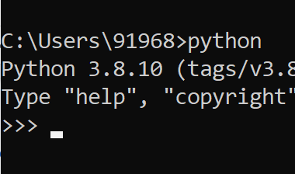
* The above is called python shell.
* Some commands used in the shell:
  + cd Desktop: to change the directory to desktop.
  + exit(): It will move to the Desktop’s Location.
  + dir: To check the file is present or not and it will display all the files present in the folder.
* To run the program from the shell:
  + - 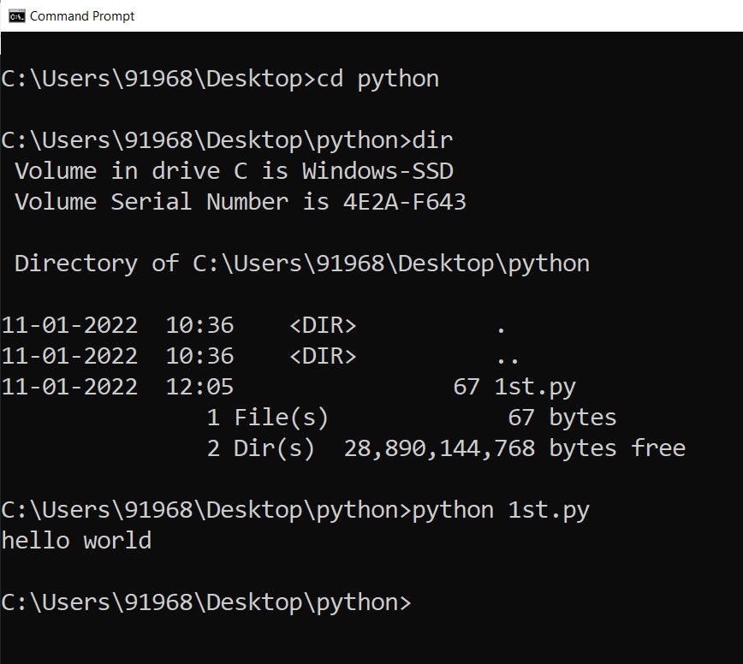
* Whenever any python program is executed, it will go to the .exe file and then it will run the program.
* Executed the first program in the vs code.
  + 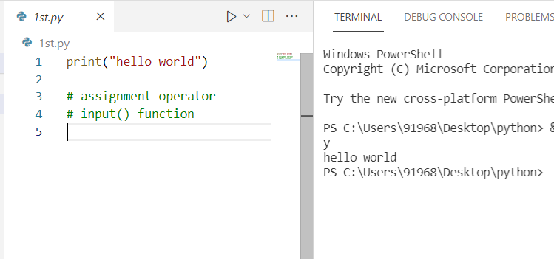
* Studied about the variables, input() function, print() function, operators, indentation, valueerror(when the input function takes any value, it is in the form of a string, hence to accept any int value, it is needed to be typecast into an int), Indentation error, Syntax error.
* Learned about assignment operator, logical operator.

**Questions:**

1. Difference between Compiler and Interpreter:
   1. **Compiler:** 
      1. It is a translator that takes the input and converts into low-level language, at a time.
      2. If any error, it will show after the execution of the whole program.
      3. It consumes more space than interpreter.
      4. It has slow speed than interpreter.
      5. It converts source code into object code.
      6. Eg: C, C++, C# etc.
   2. **Interpreter:**
      1. It ttanslates the program one statement at a time.
      2. It will show the error line by line.
      3. It consumes less space than compiler.
      4. It is faster than compiler.
      5. It does not convert source code into object code instead it will scans it line by line.
      6. Eg: Python, Perl, Ruby etc.
2. Difference between interactive mode and script mode.
   1. **Interactive Mode:**

Basically, once we write any code, and hit ‘Run’, it will immediately give us the output, on the same window. For interactive mode, text editor is used e.g: Visual Studio Code, Pycharm etc.

Eg:

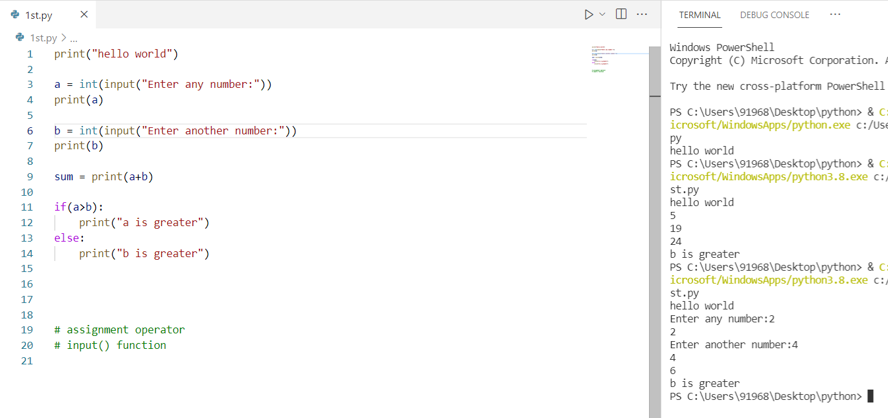

* 1. **Script Mode:**

In the script mode, the program is written in a file, eg: notepad, which is saved with the extension of “.py”. For execution of this type of program, we have to use command prompt. Open the cmd and type: python filename.py and then hit enter.

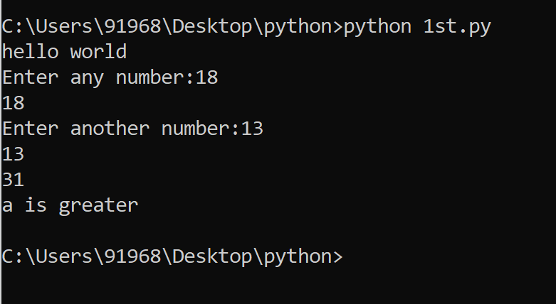

1. What is python Shell?

It is basically, a command line tool, that interprets the python program and gives output.

1. To build a python program to build a simple calculator.

Code:

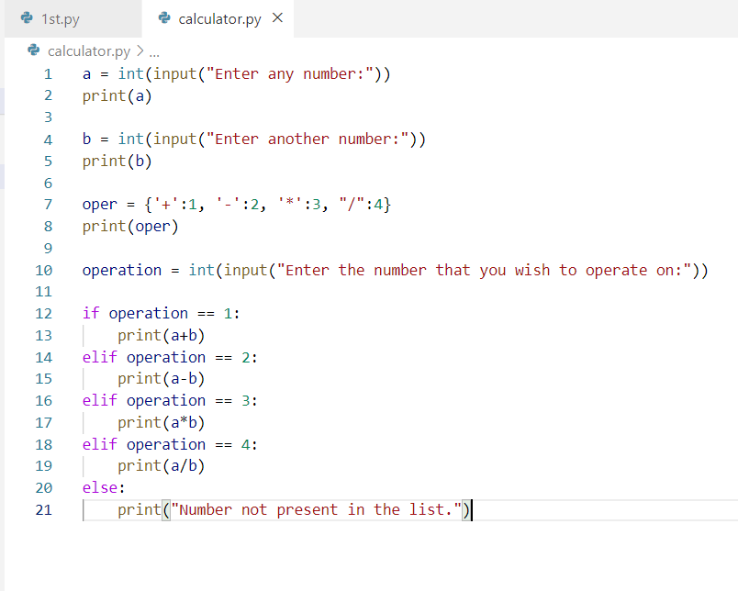

Output:

